Project Preparation
Title of Project - "Comparative Analysis of of Two Mutual Funds"
Randomly select two mutual funds :
Fund 1) Fidelity Advisor Blue Chip Grow - FBCJX
Fund 2) JPMorgan US Equity I – JUESX

Random selection of funds from 507
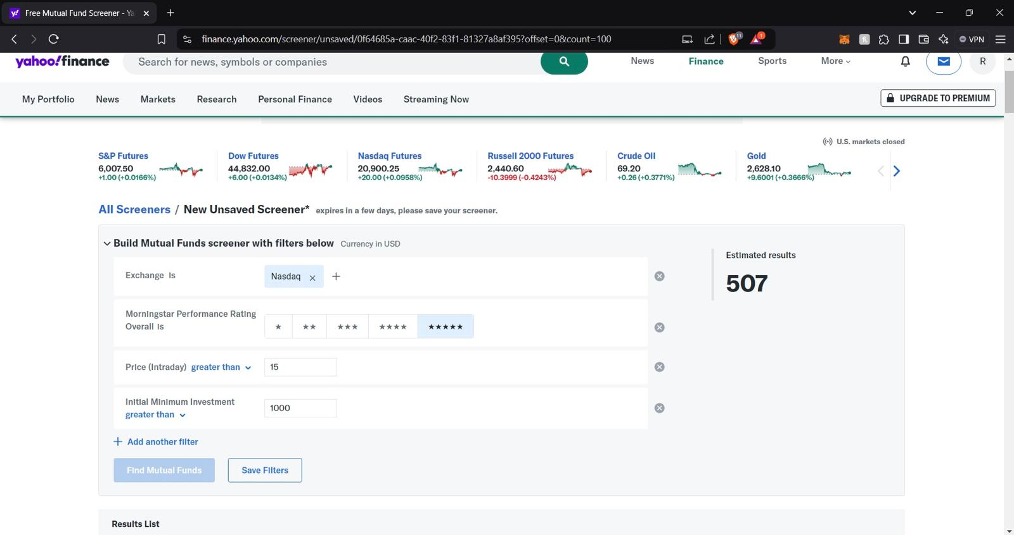

Using RANDBETWEEN to get column number of fund for random generation.
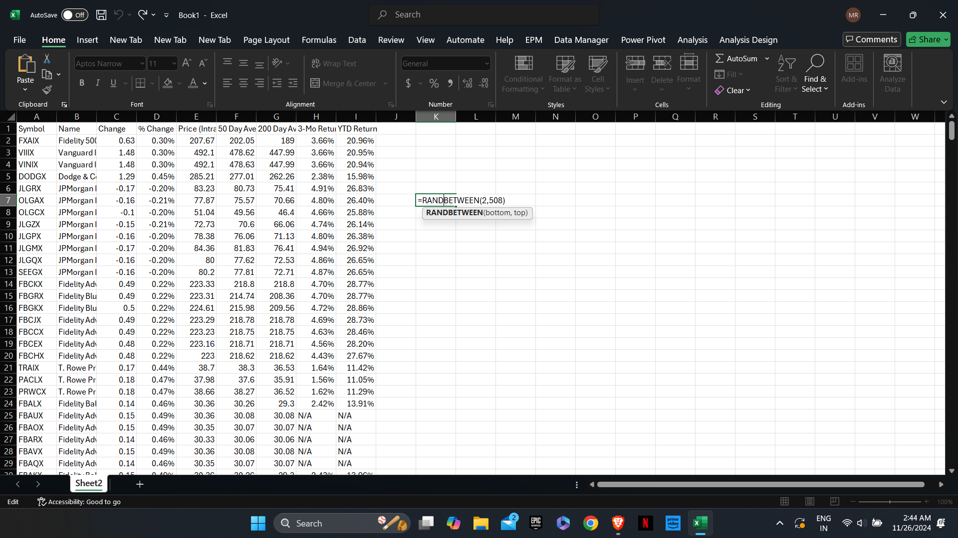


Fund 1)
3-year historical data from October 1st,2021 to September 30th ,2024.
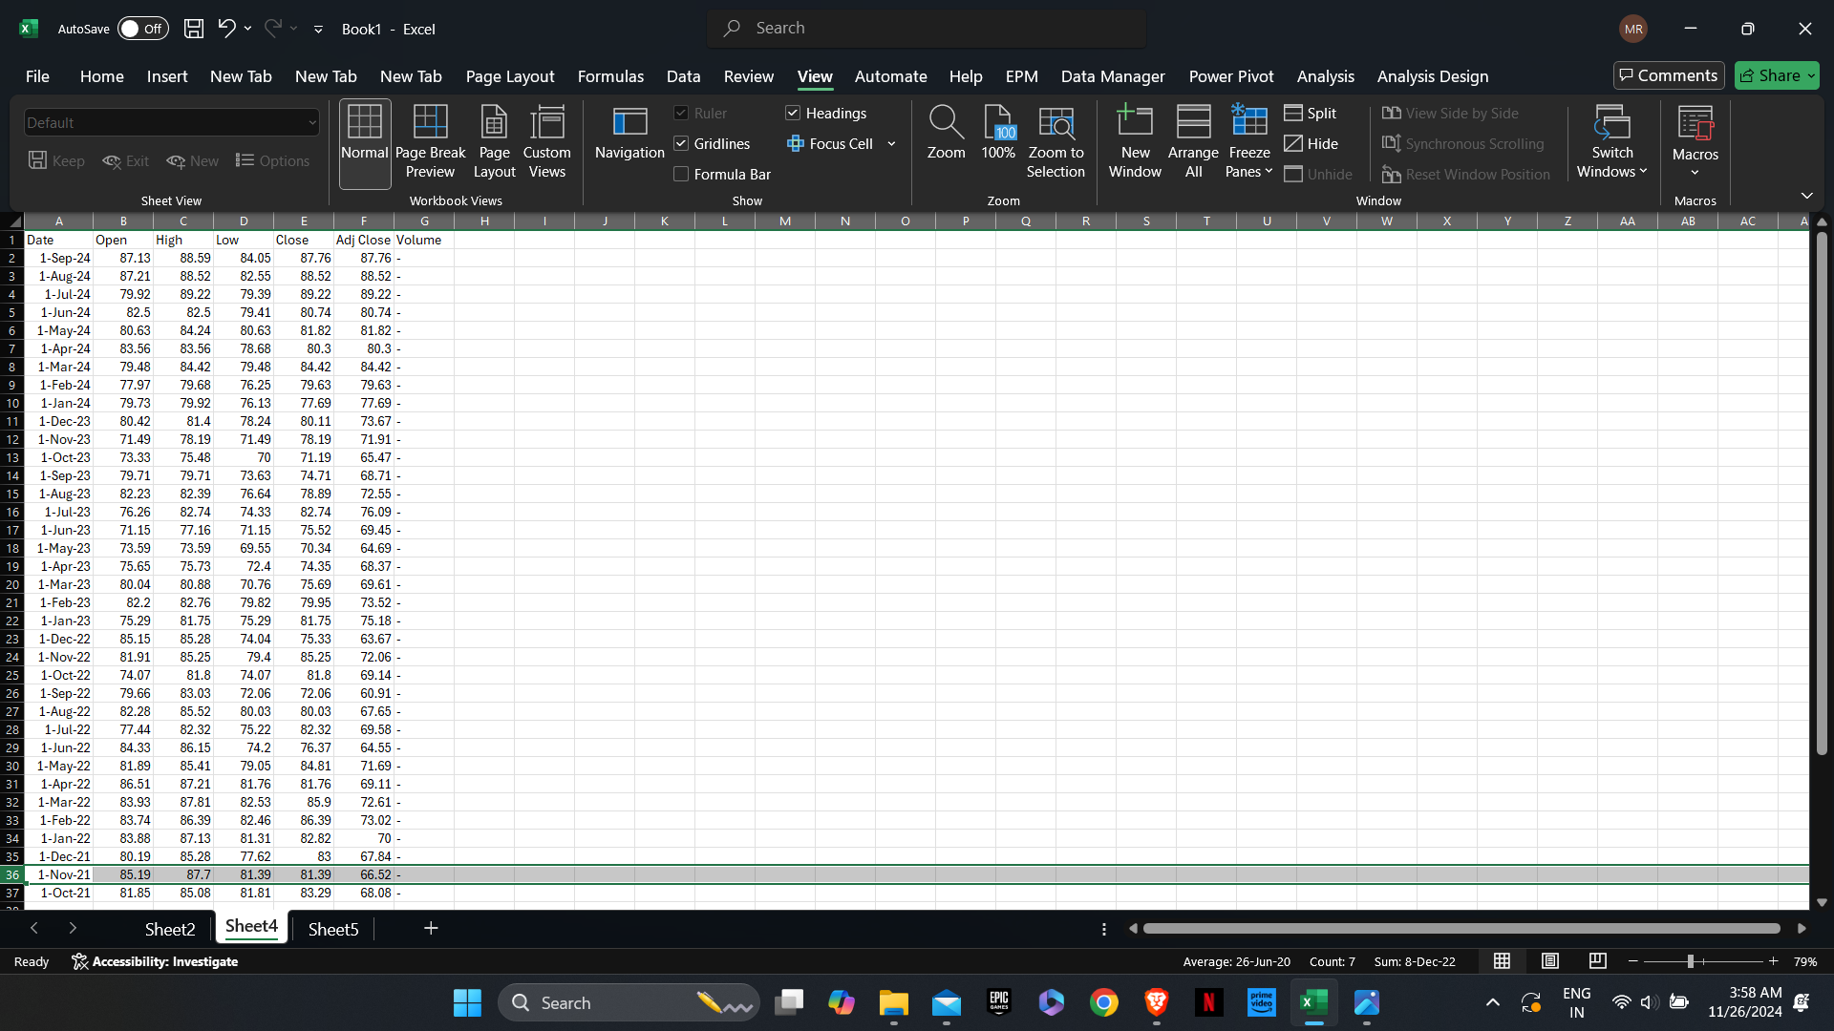

use this formula to calculate monthly return of Fund 1
$$Monthly Return=100×\left(\frac{Adjusted Closing Price on the First day of Month}{Adjusted Closing Price on the First Day of Previous Month}-1\right)$$

Fund 2)
3-year historical data from October 1st,2021 to September 30th ,2024.
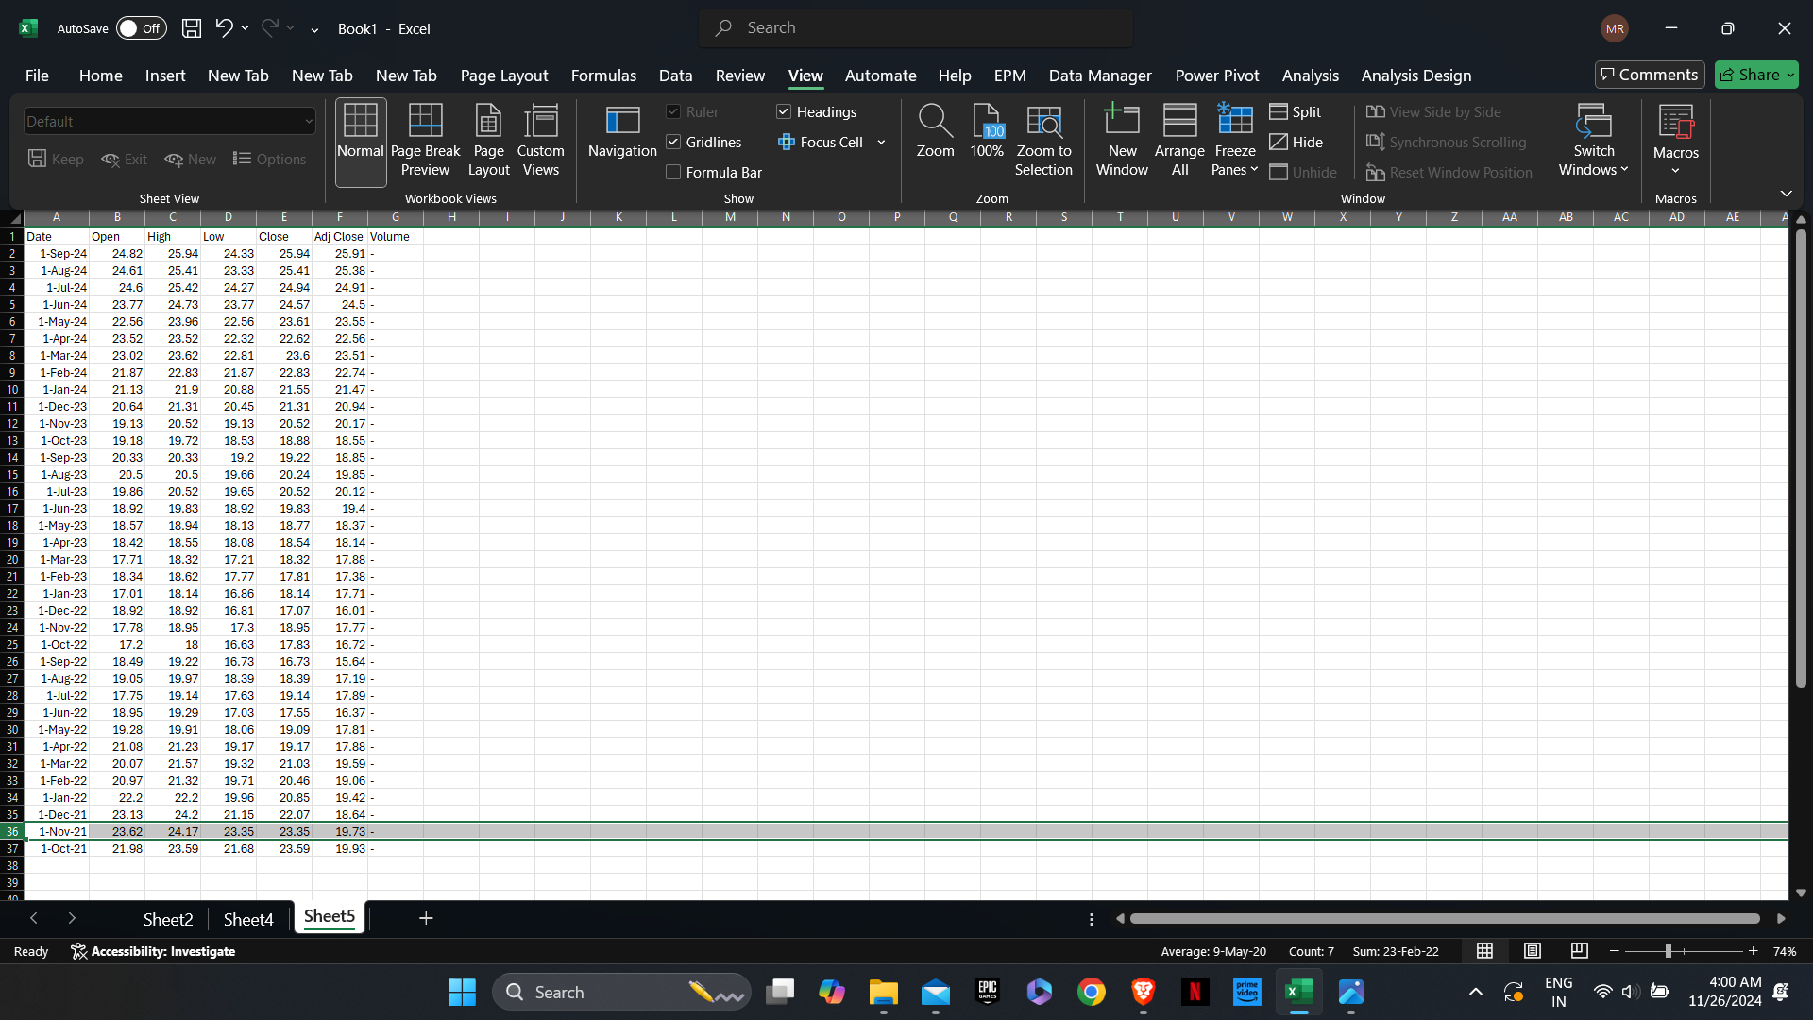

use this formula to calculate monthly return of Fund 2
$$Monthly Return=100×\left(\frac{Adjusted Closing Price on the First day of Month}{Adjusted Closing Price on the First Day of Previous Month}-1\right)$$


- Using descriptive statistics to compare the risk and reward for each fund (Table & Charts)
Comparing Fund 1 and Fund 2

- At the 5% significance level, determine whether the mean return differ (Hint: this is a matching-pair sample). Discuss any assumption that you made for the analysis.

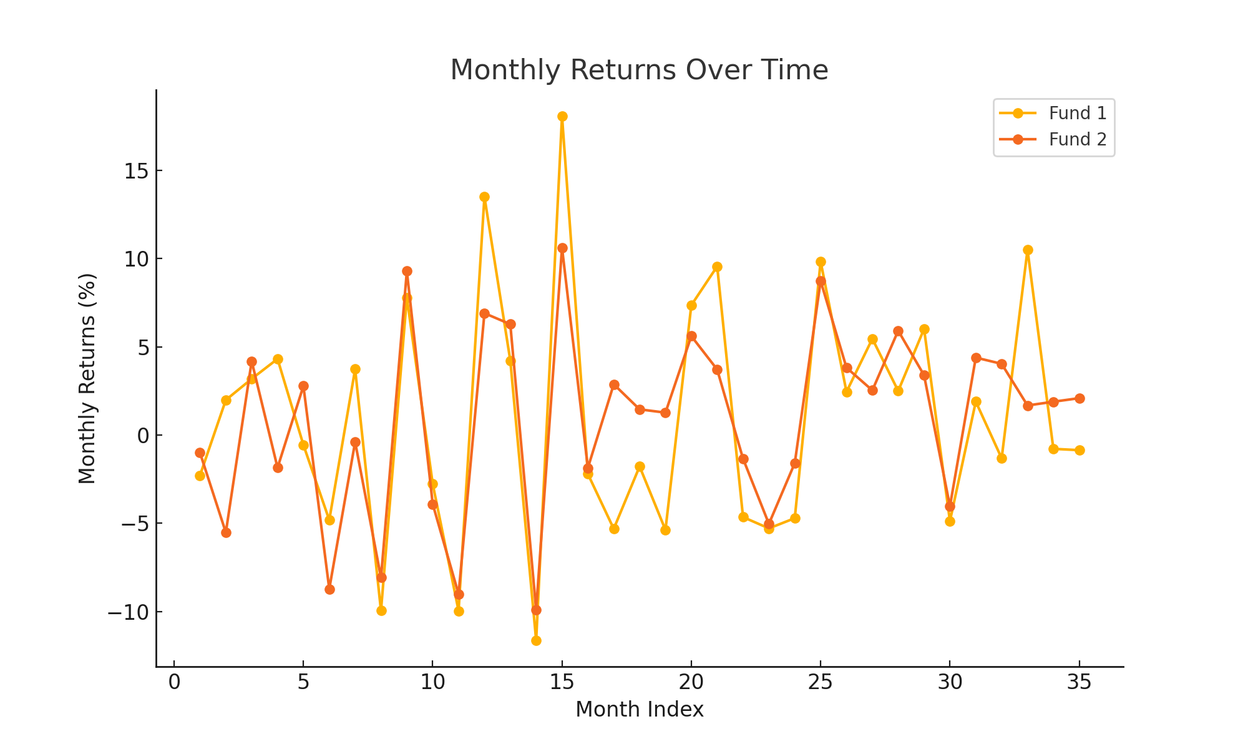

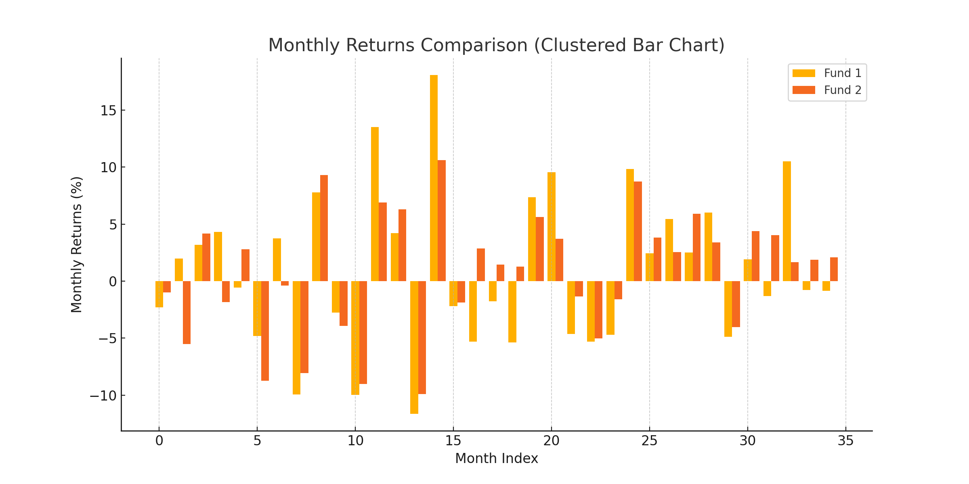

Descriptive Statistics:
I have provided a table that compares the descriptive statistics for both funds, including mean, standard deviation, and other key metrics. The graph above illustrates the monthly returns of both funds over time, giving you a visual comparison of their performance.

Paired t-test Results:
The t-statistic is 0.083, and the p-value is 0.934. Since the p-value is less than the significance level of 0.05, we fail to reject the null hypothesis. This suggests that there is no statistically significant difference in the mean returns between the two funds.

Assumptions:
- Normality: We assumed that the differences between the returns of the two funds are normally distributed, which is standard for paired t-tests.
- Paired Sample: The same time period was used for both funds, making this a matched-pair comparison.

Descriptive Statistics
Q1: Which mutual fund has a higher return?
- Fund 1 has an average monthly return of 0.95%.
- Fund 2 has an average monthly return of 0.89%.
Fund 2 has a higher return.
Q2: Which mutual fund has a higher risk?
- The standard deviation (risk) for Fund 1 is 6.80%.
- The standard deviation (risk) for Fund 2 is 5.29%.
Fund 1 has higher risk.
Q3: Based on the confidence intervals, do you think their mean returns are significantly different?
- The 95% confidence interval for Fund 1's mean return is between −1.30% and 3.20%.
- The 95% confidence interval for Fund 2's mean return is between −0.86% and 2.64%.
Since the confidence intervals overlap, this further supports the conclusion that their mean returns are not significantly different, consistent with the earlier result from the paired t-test (p-value = 0.934).

Boxplots for both and difference 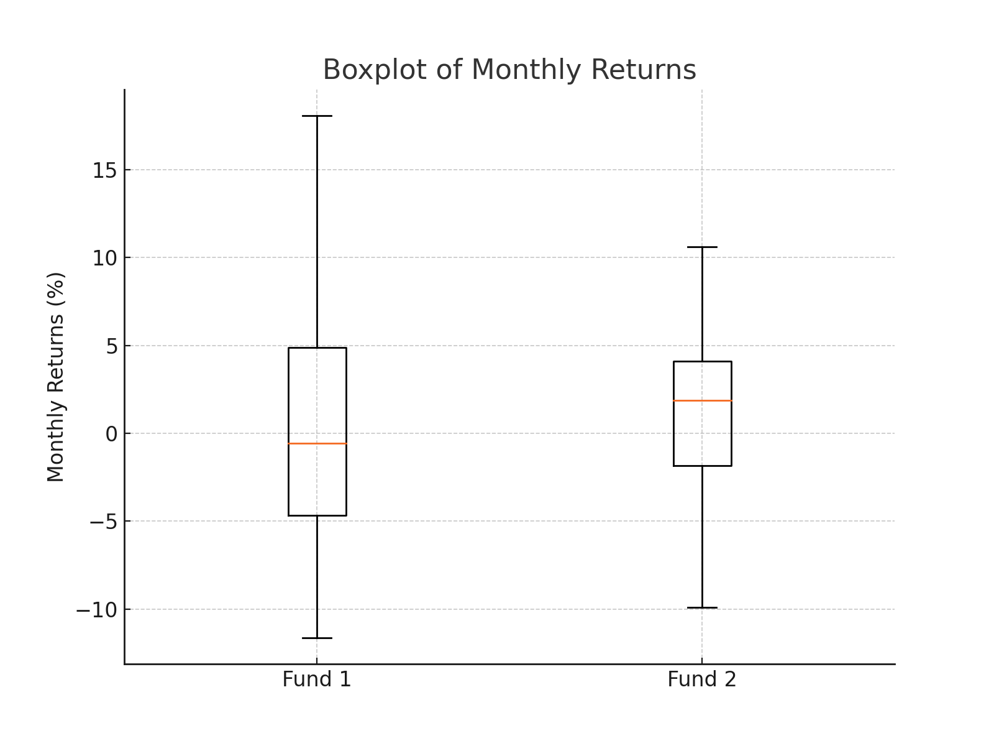
(Fund 1 and Fund 2)
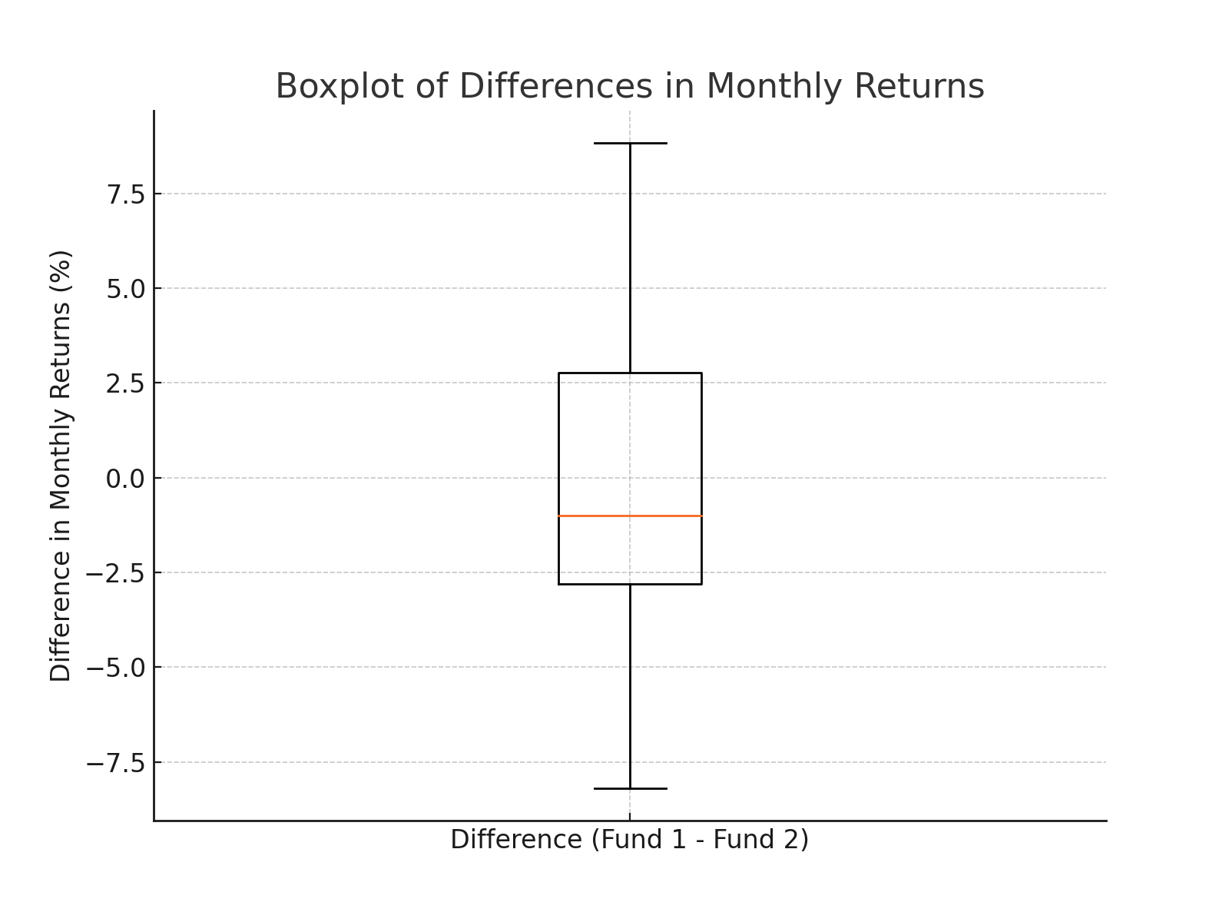

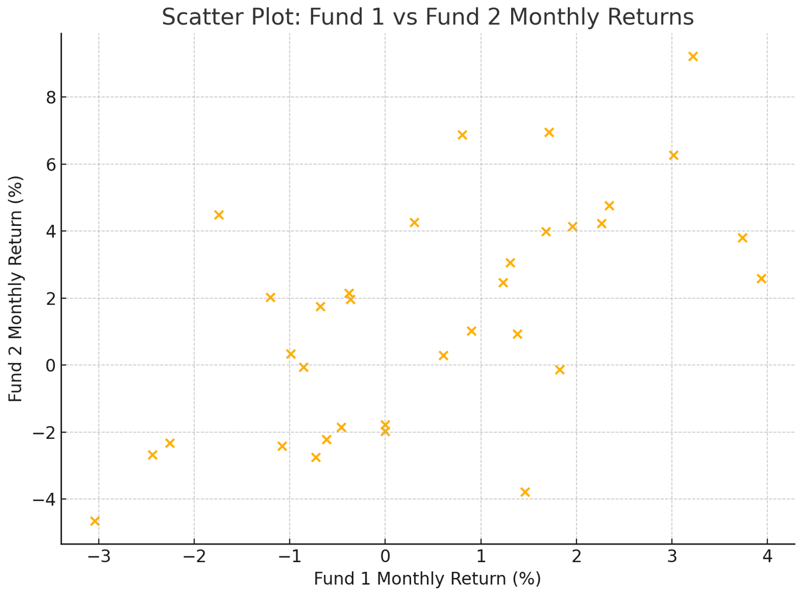
Visual Analysis:
- Boxplots:
  - The first boxplot compares the distribution of monthly returns for Fund 1 and Fund 2. It shows the spread and differences in returns between the two funds.
  - The second boxplot represents the difference in monthly returns between the two funds.
- Scatter Plot:
  - The scatter plot visualizes the relationship between the monthly returns of Fund 1 and Fund 2. There is a positive correlation between the two funds, as the points trend upward.
Q: Are the two mutual funds correlated?
Yes, the correlation coefficient between the two funds is 0.63, which indicates a moderate positive correlation. This suggests that when one fund performs well, the other tends to perform well too, though not perfectly aligned

Q4) State null hypothesis and alternative hypothesis
Specify the level of significance
Select the test statistic
State decision rule
Conduct test
State your conclusion
Comments on the testing result
H0: μD ≤ 0 μD =μ1 - μ2
HA: μD > 0
H0: μD = 0
HA: μD ≠ 0

The steps to follow your hypothesis testing procedure based on your provided hypotheses:
1. State Null and Alternative Hypotheses
- Null Hypothesis (H0): μD=0\mu_D = 0μD​=0 (There is no difference in the mean returns of the two mutual funds, μ1−μ2=0\mu_1 - \mu_2 = 0μ1​−μ2​=0).
- Alternative Hypothesis (HA): μD≠0\mu_D \neq 0μD​=0 (There is a significant difference in the mean returns of the two mutual funds).
2. Specify the Level of Significance
- The level of significance (alpha)α is typically 0.05 (5%).
3. Select the Test Statistic
- We'll use the paired t-test because we are comparing the mean difference between two related samples (monthly returns of the two mutual funds).
4. State the Decision Rule
- If the p-value is less than or equal to 0.05, we will reject the null hypothesis.
- If the p-value is greater than 0.05, we will fail to reject the null hypothesis.
5. Conduct the Test
- We've already conducted a paired t-test. The t-statistic is 0.083, and the p-value is 0.934.

6. State Your Conclusion
- Since the p-value (0.934) is greater than 0.05, we fail to reject the null hypothesis. There is no statistically significant difference in the mean monthly returns of Fund 1 and Fund 2
7. Comments on the Testing Result
- The test results indicate that there is no significant difference between the returns of the two mutual funds at the 5% significance level. This implies that the performance of these two funds do differs significantly, and their returns are statistically equivalent.

Q5) Predict monthly returns for October 2024 and compare them with actual monthly returns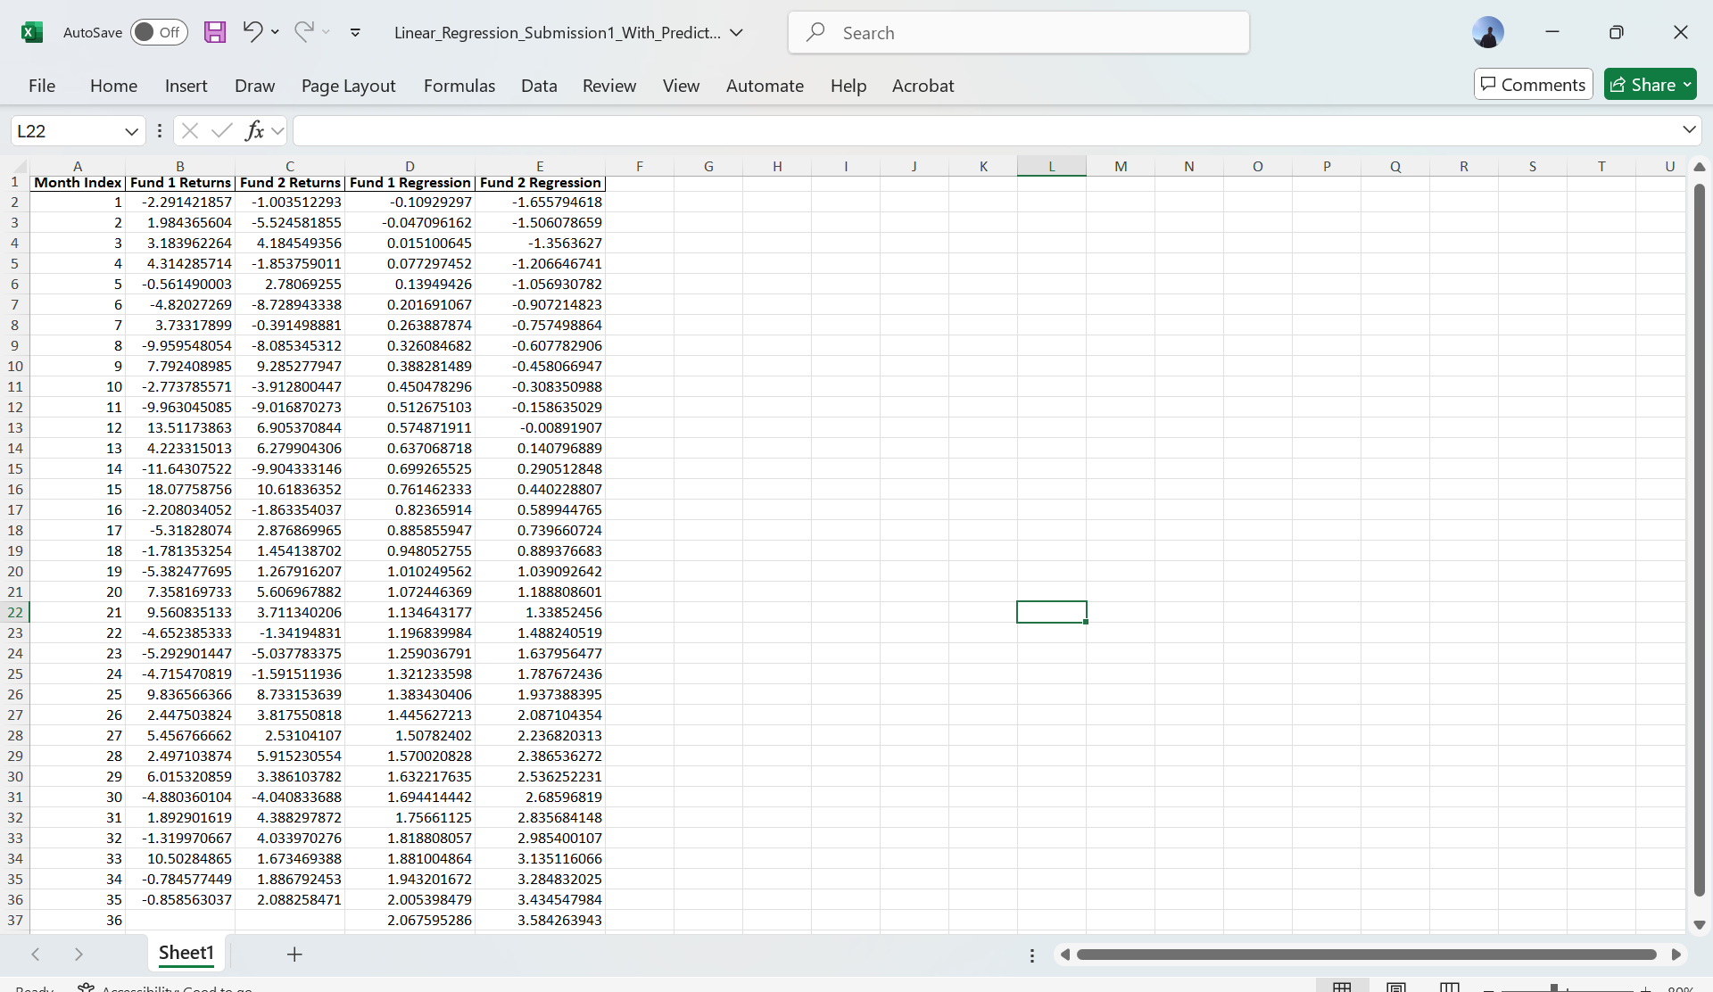

To predict the monthly returns for October 2024, we can use:
Linear regression based on the trend.
The predicted monthly returns for October 2024 are:
- Fund 1: 2.06%
- Fund 2: 3.58%

Definitions for important terms used in the project:
1. Mean Return: The mean return represents the average return over a given period. It is calculated as the sum of all returns divided by the number of periods. It is a measure of the fund's performance.
2. Standard Deviation: Standard deviation measures the volatility or risk of returns. A higher standard deviation indicates higher variability in returns and, therefore, greater risk.
3. Paired t-test: A paired t-test is a statistical method used to determine whether there is a significant difference between the means of two related groups. In this case, the related groups are the monthly returns of the two funds over the same period.
4. Confidence Interval: A confidence interval provides a range of values that is likely to contain the true population parameter (e.g., mean return). For instance, a 95% confidence interval implies that there is a 95% probability that the interval contains the true mean.
5. Correlation: Correlation measures the strength and direction of the relationship between two variables. A correlation coefficient between -1 and 1 indicates the degree of association, with 1 being a perfect positive correlation, -1 a perfect negative correlation, and 0 no correlation.
6. Boxplot: A boxplot is a graphical representation of the distribution of data. It shows the median, quartiles, and potential outliers, making it easy to visualize variability and compare distributions.
7. Linear Regression: Linear regression is a statistical technique used to model the relationship between a dependent variable and one or more independent variables. Here, it was used to predict future returns based on historical data.

